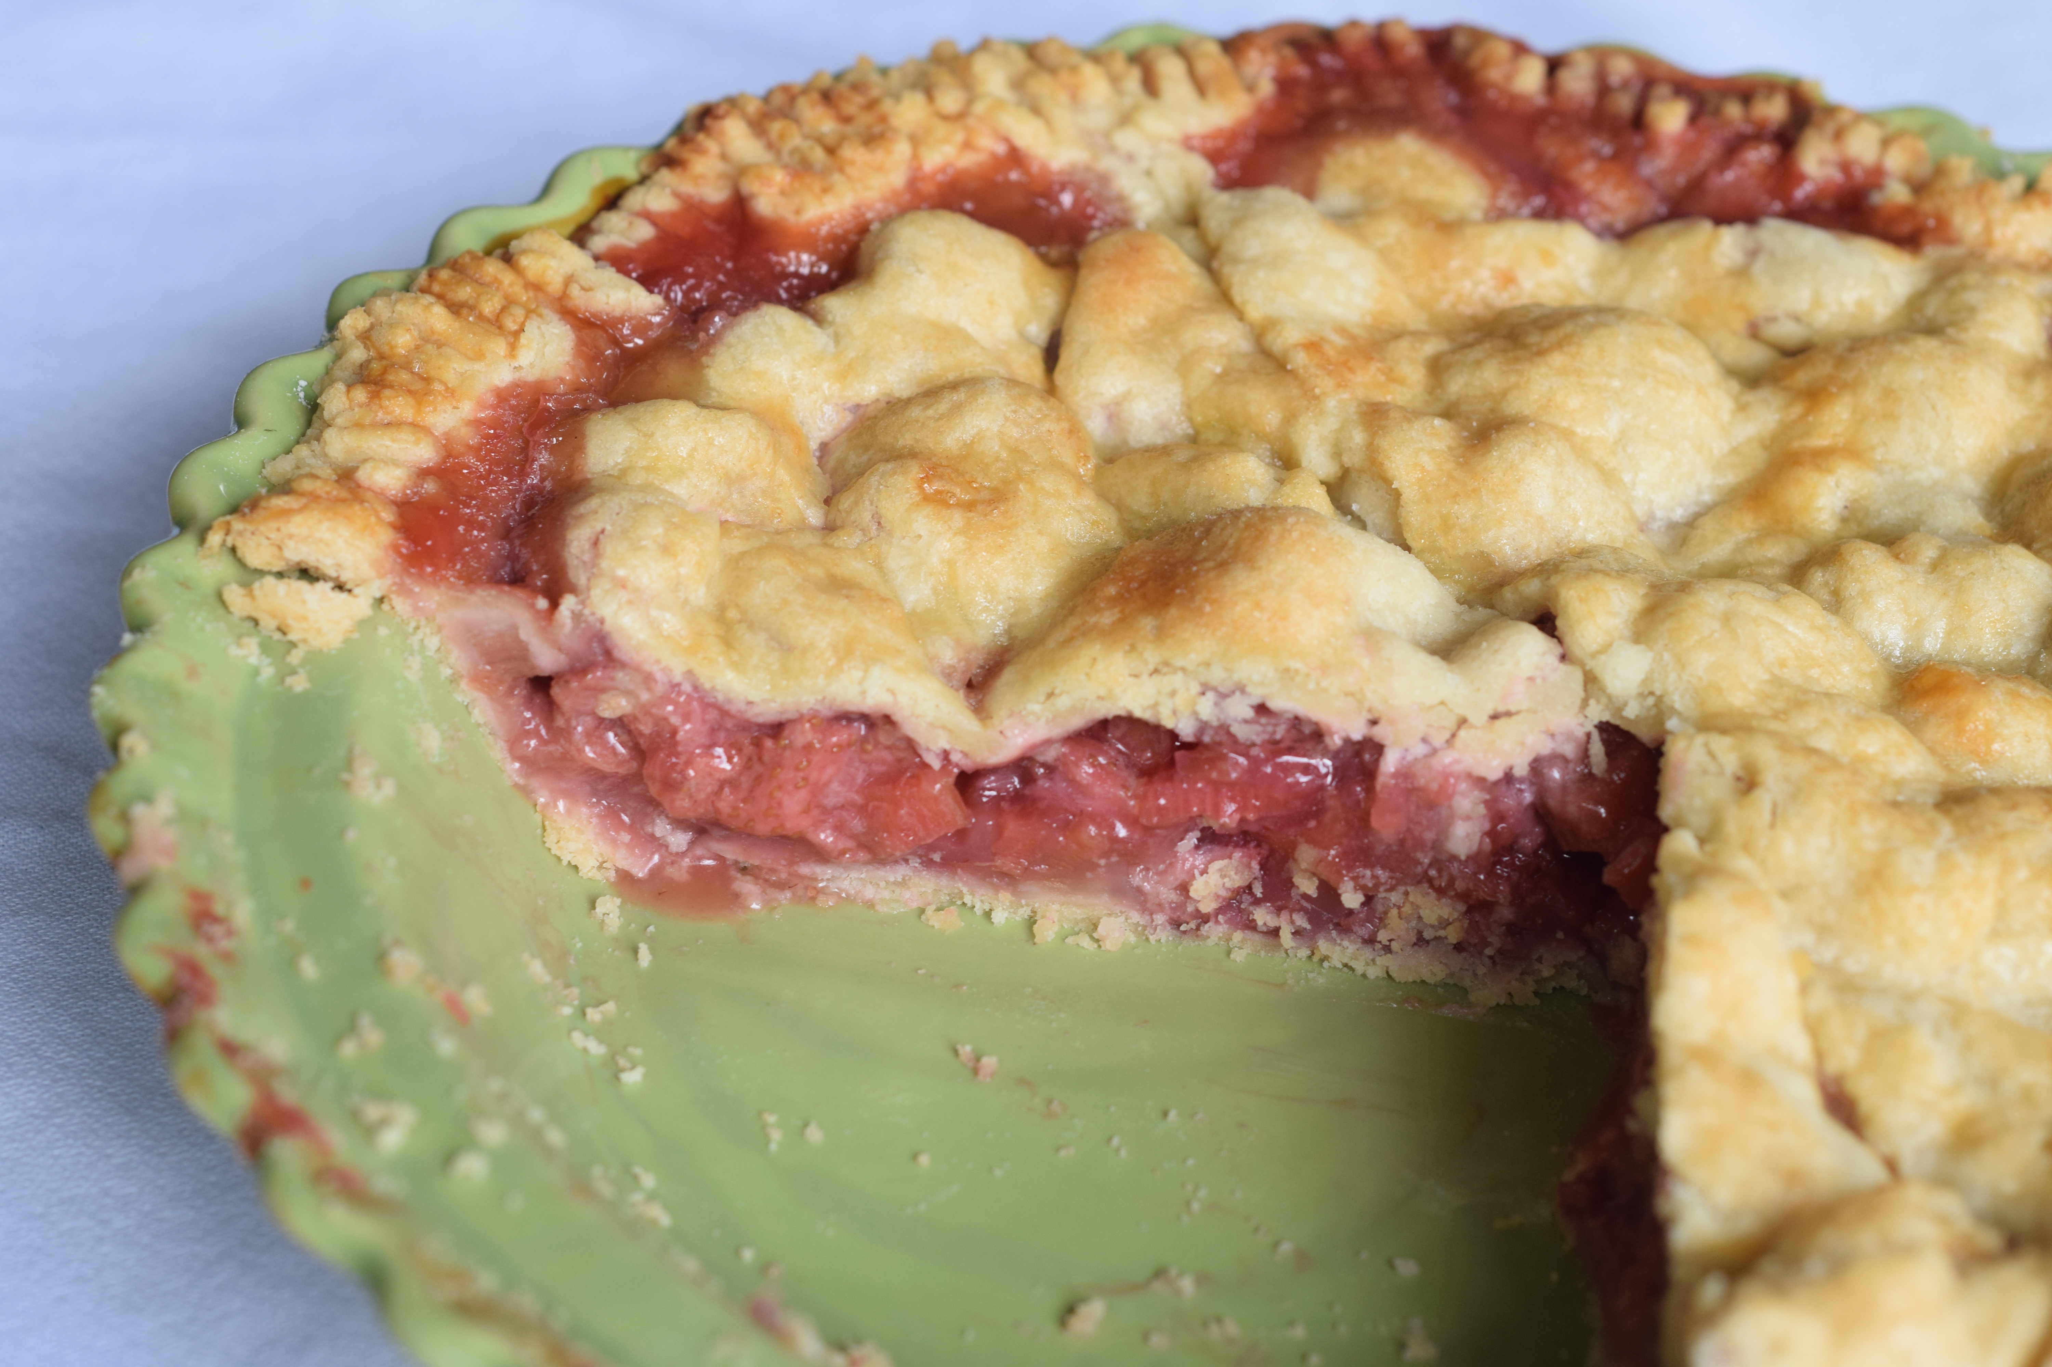
Strawberry Rhubarb Pie with Almond Flour Crust

Almond Flour Double Pie Crust:
The almond flour added to this pie crust adds flavor and tenderness. It is not gluten-free.

2 cups all-purpose flour
1/2 cup almond flour
1/2 cup salted butter, cut into 8 pieces
6 tablespoons cold shortening, cut into 8 pieces
2 to 3 tablespoons ice cold water

Filling:
3 cups thinly sliced rhubarb
3 cups quartered strawberries (smaller if berries are very large)
1/2 cup granulated sugar
1/4 cup cornstarch
1 teaspoon lemon juice
1 teaspoon vanilla extract
2 tablespoons salted butter, cut into small pieces
1 large egg
1 tablespoon milk

Crust:
Pulse first 5 ingredients in a food processor 1 or 2 times to mix together. Add butter and shortening and pulse 4 or 5 times until pieces are about the size of large peas. (They will get a little smaller when pulsing to add water).
Pulse 3 or 4 times while adding water 1 tablespoon at a time through the food chute just until mixture starts to form a ball. Be careful not to add too much water or over mix. Shape mixture into a ball and cut in half. Place each half on a sheet of plastic wrap and cover loosely. Press gently into a disk shape and refrigerate at least 1 hour up to 3 days. (Crust can also be made with traditional method of using a bowl and pastry blender but I prefer the food processor. It takes half the time.)

Preheat oven to 400°. On a lightly floured countertop, roll one of the dough disks into an 11-inch circle. Using a large flat spatula or dough scraper, gently make sure dough is not stuck to the counter. Fold half of dough onto the other half forming a half moon shape. Using spatula or dough scraper, gently place dough on one half of a 9-inch pie plate. Unfold the halved pie dough to cover the bottom of the pie plate. Place pie plate in refrigerator and remove the second disk.

Combine rhubarb, strawberries, sugar, cornstarch, lemon juice, and vanilla in a large bowl and set aside.

Roll out the second disk of dough with same procedure up to folding it in half. Spoon strawberry-rhubarb filling into prepared pie plate and place small pieces of butter over filling. Gently place folded pie dough over the filling and unfold to cover filling. Trim edges of both layers with scissor so there’s about 1 inch overhang. Fold edges under and crimp. For the pie in the photo, I trimmed the edges with no overhang and pressed down with a fork.

Lightly whisk egg and milk together with a fork and brush over the top crust. Bake at 400° for 20 minutes. Without opening the oven door, reduce oven temperature to 350° and continue baking for 25 to 30 minutes or until crust is golden brown and filling is bubbly.

Let pie cool completely on a wire rack. Serve with vanilla ice cream, if desired.

