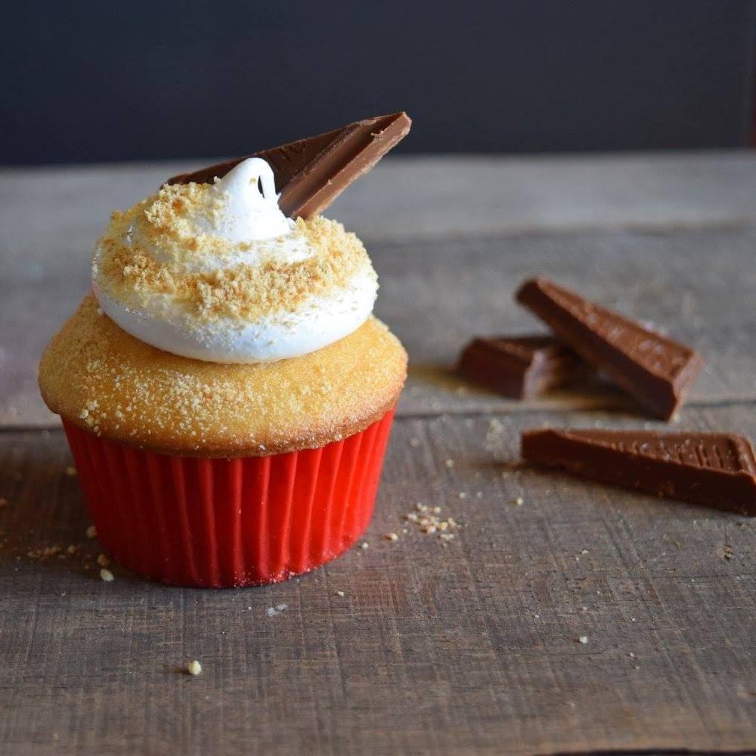

Campfire S’mores Cupcakes

Author: GritsAndGouda.com
Yield: 24 cupcakes

Quick Mix Vanilla Cupcakes:
2 1/2 cups all-purpose flour
2 cups granulated sugar
1 1/2 teaspoons baking powder
1 teaspoon baking soda
3/4 teaspoon salt
3 large eggs
1/2 cup vegetable oil or a light olive oil
3/4 cup whole milk
1/2 cup sour cream
2 teaspoons vanilla extract
1/4 cup graham cracker crumbs
1 (7-oz) bar Hershey’s milk chocolate bar, broken into little bars and cut diagonally

1. Preheat oven to 350°. Place 24 red paper liners in muffin pans.
2. Stir together flour, sugar, baking powder, baking soda, and salt in a bowl.
3. Place eggs in the bowl of an electric mixer and beat 20 seconds or just until lightly beaten. Gradually add oil, milk, sour cream, and vanilla beating after each addition just until incorporated.
4. Add dry ingredients to egg mixture and beat on medium low speed until smooth. (Technically muffin method says stir just until moistened, but this is a cross between cake and muffin method.)
5. Pour batter into paper liners about two-thirds full. Bake at 350° for 14 to 15 minutes or until toothpick inserted in center comes out clean. Let cool in the pans 2 minutes, then cool completely on wire racks.
6. Prepare Marshmallow Frosting. Pipe Marshmallow Frosting onto cupcakes and immediately sprinkle about 1/2 teaspoon graham cracker crumbs on the frosting and press one diagonally cut chocolate bar piece into frosting. Don’t wait until all cupcakes are frosted to sprinkle the crumbs and place the chocolate-the frosting will firm up and the crumbs will slide off.

Marshmallow Frosting (Seven Minute Frosting)
Yield: about 4 cups

1 1/2 cups granulated sugar
2 large egg whites, lightly beaten
1/3 cup water
2 tablespoons light corn syrup
1 teaspoon vanilla extract

1. Stir together sugar, egg whites, 1/3 cup water and corn syrup in a medium-size metal or heat-proof bow; beat at low speed of a hand mixer until combined. Pour enough tap water in the bottom of a medium-size saucepan to reach a depth of 1/2 inch. Bring water to a boil; place bowl with sugar mixture over saucepan. You have created a double boiler. If you have one, you can you it but I like the bowl because of the rounded bottom of a bowl.
2. Beat at high speed of the hand mixer 7 minutes over medium-low heat or until stiff peaks form. Remove from heat; add vanilla and beat just until combined. Use immediately because it will start to firm up quickly.

